**Project Report Template**

**Title of Project:** ProjectMate  
**Name of the Innovator:** Justin B David  
**Start Date:** 27-10-2025

**End Date: 31-10-2025**

***Day 1: Empathise & Define***

*Step 1: Understanding the Need*

* Which problem am I trying to solve?

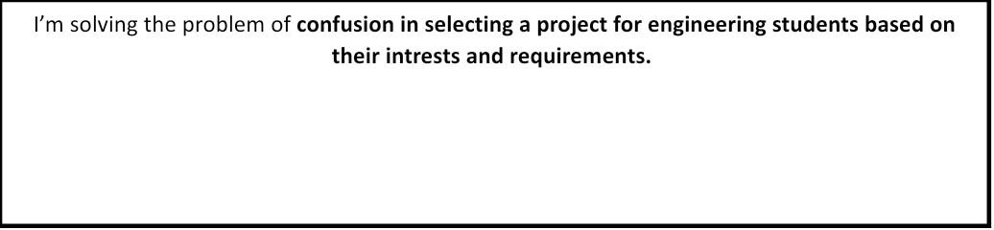

* Who is affected by this problem?
* How did I find out about this? [Select whichever is applicable]
* Interviews
* Observation
* Online Research
* AI Tools

*Step 2: What is the problem?*

The problem is that **the engineering students have a lot of confusion in selecting a project during their pre final year and final year ,which consumes a lot of time in just selecting a project and getting rejected by their project guides.**

Why is this problem important to solve?

This problem is important to solve because **the students loose their precious time in just selecting a project and which also create a lot of confusion in selecting it based on their ideas ,capabilities and requirements and get it approved by the project guide.**

**Take-home task**

Ask 2-3 people what they think about the project:

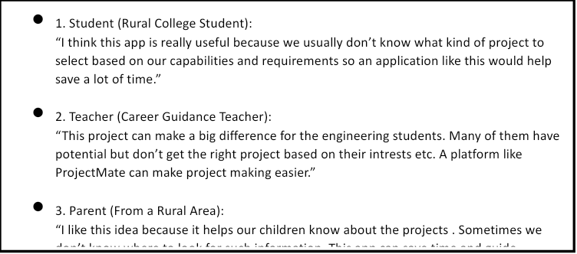

*AI Tools you can use for Step 1 and 2:*

**AI Tools Used:**

**1. Meta MGX**

* **Used as a no-code development tool to design and deploy the *CareerPath* app.**
* **It helps create interactive workflows, user interfaces, and logic without programming.**
* **Ideal for building features like user registration, location-based data, and skill modules.**

**2. ChatGPT**

* **Used for idea generation, content structuring, and chatbot conversation design.**
* **Helped in framing the AI-powered virtual assistant’s responses for guiding students.**
* **Also useful for generating career recommendations, FAQs, and improving user interaction flow.**

**3. Chatbot References (Structure Design):  
To design the AI virtual assistant, you can take reference from:**

* **Google Dialogflow – for understanding intent detection and response flow.**
* **IBM Watson Assistant – for creating structured Q&A and personalized career guidance.**
* **Microsoft Bot Framework – for understanding conversation trees and user profile integration.**

***Day 2: Ideate***

*Step 3: Brainstorming solutions*

* List **at least 5 different solutions** (wild or realistic):
* **AI Chatbot for Career Guidance** – A virtual assistant that helps students choose the right career and find job opportunities.
* **Skill Learning Website** – A platform to improve communication, aptitude, and soft skills through online lessons.
* **Career Awareness Workshops** – Conducting offline or online sessions in rural schools and colleges to guide students.
* **Mobile App for Scholarship Updates** – Sends alerts about available scholarships and government schemes.
* **Community Mentor Program** – Connects students with mentors or professionals from nearby areas for real guidance.
* **CareerPath Platform**  – A complete digital platform combining AI guidance, skill modules, and location-based opportunities built using **Meta MGX**, designed to empower rural youth.

*Step 4: My favourite solution:*

*My favorite solution is* ***CareerPath****, a complete digital platform designed to empower rural youth. It combines an* ***AI-powered virtual assistant*** *for personalized career guidance,* ***skill development modules*** *for employability, and* ***location-based suggestions*** *for colleges, training centers, and jobs. Built using* ***Meta MGX****, the app is easy to access, update, and use anytime, making it a* ***long-term, practical, and impactful solution*** *for students in rural areas.*

*Step 5: Why am I choosing this solution?*

I am choosing CareerPath because it combines AI guidance, skill development, and location-based opportunities in one platform. It is easy to use, accessible anytime, and designed to empower rural youth to make informed career decisions.

*AI Tools you can use for Step 3-5:*

**AI Tools for Step 3–5**

**1. Meta MGX**

* Used to **design and build the CareerPath app** without coding.
* Helps create the **AI assistant, skill modules, and location-based features**.

**2. ChatGPT**

* Helps **brainstorm solutions** and generate ideas for career guidance features.
* Can **structure conversations** for the AI virtual assistant.
* Assists in writing content for skill modules, FAQs, and recommendations.

**3. AI Chatbot References (for design and flow)**

* **Dialogflow** – Understands user intent and conversation flow.
* **IBM Watson Assistant** – Helps design structured Q&A for personalized guidance.
* **Microsoft Bot Framework** – Shows how to connect user inputs with recommendations and actions.

**4. AI Research Tools**

* **Google Scholar / Research AI** – For exploring existing solutions and innovative ideas for Steps 3–5.
* **AI Text & Summarization Tools** – Helps summarize solutions, select the best approach, and present them clearly.

*AI Tools you can use for the take-home task:*

**Canva AI/CoPilot AI/Meta AI:** Use these mobile-based tools to generate images for the solution they want to design

***Day 3: Prototype & Test***

*Step 6: Prototype – Building my first version*

What will my solution look like?

* **Home Screen:** Welcomes the user and asks for basic info like age, education, and location.
* **AI-Powered Virtual Assistant:** Chat interface where users can ask about careers, scholarships, and job opportunities.
* **Skill Development Section:** Short modules for English, aptitude, and soft skills with interactive exercises.
* **Location-Based Recommendations:** Map or list showing nearby colleges, training centers, and relevant job options.
* **Profile Dashboard:** Tracks the user’s progress, completed skill modules, and saved opportunities.

**Design Style:**

* Simple, intuitive, and easy to navigate for rural youth.
* Bright and engaging visuals to make learning and exploration fun.
* Mobile-friendly layout for easy access on smartphones.

**Prototype Tools:**

* Built using **Meta MGX**, no coding required, with all features **interactive and testable**.

What AI tools will I need to build this?

**AI Tools Needed to Build CareerPath**

1. **Meta MGX**
   * No-code platform to **design and deploy the app**.
   * Allows building **interactive screens, chat interfaces, and skill modules** without coding.
2. **ChatGPT (or similar LLMs)**
   * To **generate content, conversation flows, and career guidance responses**.
   * Can help **personalize recommendations** for users based on their profile and location.
3. **AI Chatbot Design References**
   * **Google Dialogflow / IBM Watson Assistant / Microsoft Bot Framework**
   * To **structure conversation logic** and handle user queries effectively.
4. **AI Recommendation Tools** *(Optional but useful)*
   * For **matching students with careers, scholarships, and nearby opportunities**.
   * Could use **ML-based ranking algorithms** or **existing AI APIs** for personalization.
5. **AI Data Analysis Tools** *(Optional for insights)*
   * **Python AI libraries (Pandas, Scikit-learn)** or **AI analytics platforms**
   * To analyze user interactions and improve recommendations over time.

What AI tools I finally selected to build this solution?

1. **Chat GPT**
2. **Metamgx**

**< Build The Innovation>**

**<DASHBOAD OF THE TOOL>**

**Tool Link:**  https://mgx.dev/app/93100d95540b4277b475e06b91419a48

Internal Working of tool:

Selection of project type:

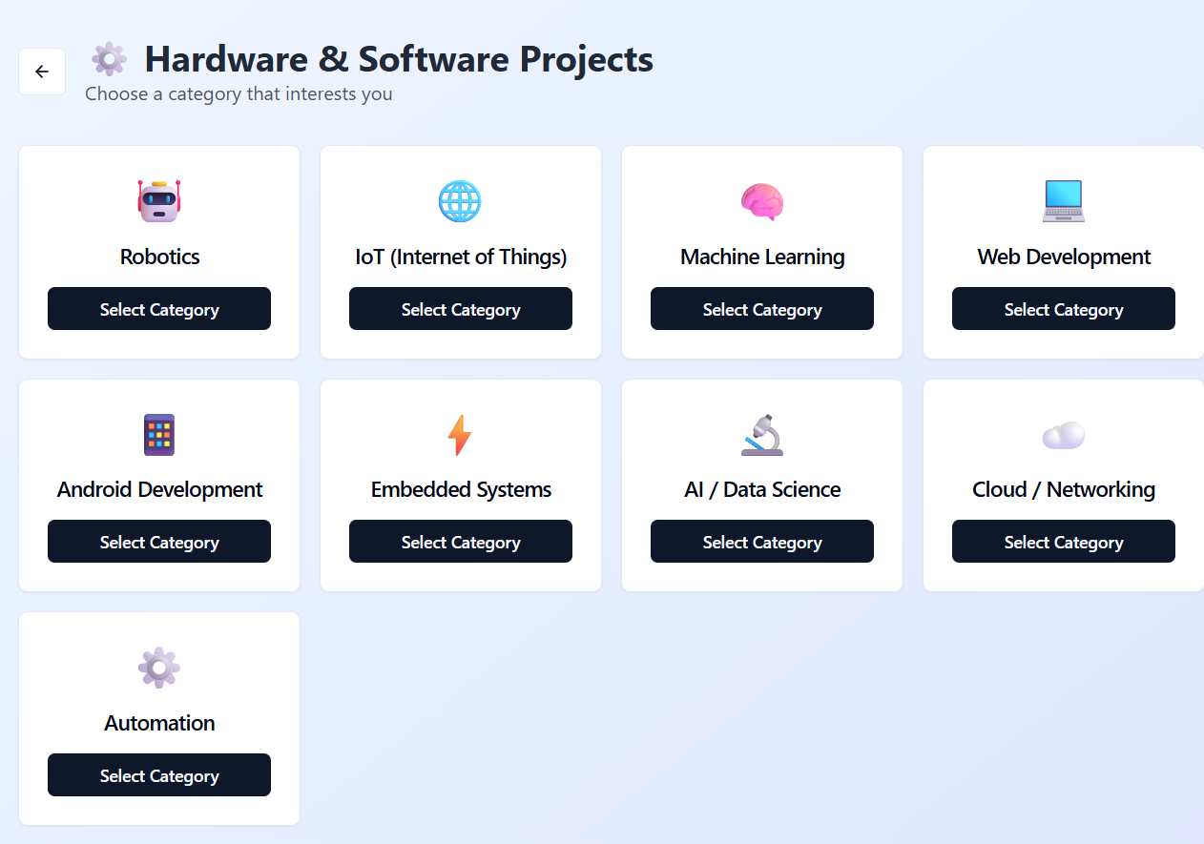

Selection of project requirements:

Adding the project suggestions and ideas:

Project recommendations and its details:

*Step 7: Test – Getting Feedback*

* Who did I share my solution with?

I shared my **ProjectMate** solution with:

* **Students from engineering collages** – to get feedback on usability and relevance.
* **Teachers and career guidance counselors** – to understand how well it supports projects making.
* **Parents of rural students** – to see if it helps their child doing the project easily without stress and confusions.
* **Peers and mentors** – for suggestions on improving features and design.

What feedback did I receive?

**Feedback: Pros and Cons**

**Pros (Positive Insights from Feedback):**

1. Users found the **AI assistant helpful** for exploring the projects and its details.
2. The concept of the platform is **promising** and shows potential for student guidance.
3. Project type and selection based suggestions were appreciated as **useful features**.

**Cons (Areas to Improve Noted in Feedback):**

1. Chatbot responses sometimes **repeat options**, which can confuse users.
2. Certain **interactive features are restricted** or not fully accessible in the prototype.
3. Limited resources and integrations mean users can only access a **basic version** of guidance and opportunities.

**My Response for The Feedback:**  
ProjectMate is an idea created using a **no-code tool (Meta MGX)**. As it’s an initial prototype, the resources and integrations are limited. To fully integrate all features and access a wider range of recommendations and projects we would need **collaborations with different platforms and organizations**. The current limitations are due to the constraints of the prototype environment, but the concept demonstrates the **potential, usability, and impact** of the platform for students.

👍 What works well: 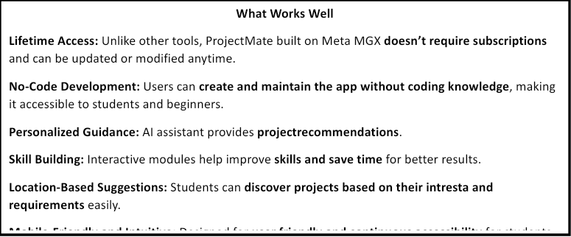

🔧 What needs improvement: 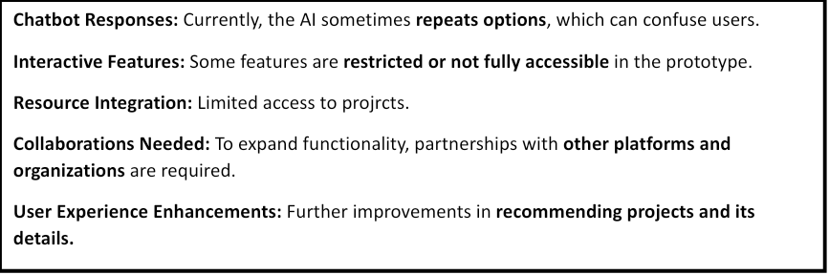

*AI Tools you can use for Step 6-7:*

**ChatGPT/Perplexity AI/Claude AI/Canva AI/Chatling AI/Figma AI/Metamgx/Gamma AI**: You can use these tools to build solutions/models or mock-up dummy prototypes

***Day 4: Showcase***

*Step 8: Presenting my Innovation:*I am presenting **ProjectMate**, a **student guidance and project selecting platform** for students:

* An **AI-powered virtual assistant** that provides personalized project guidance.
* **Project recommendation guidance.**
* **Requirements based suggestions** for students, in selecting their project.
* A **user-friendly, mobile-friendly interface** built on **Meta MGX** with lifetime access and easy updates.

**Impact:** ProjectMate helps students make informed decisions and saves time for students.

**<SHOWCASE YOUR INNOVATION TO YOUR PEERS>**

*Step 9: Reflections*

* What did I enjoy the most during this project-based learning activity?

I enjoyed **building ProjectMate using a no-code tool** and seeing my idea take a **real, interactive form**. It was exciting to **design the AI assistant, skill modules, and selection based features**, and imagine how it could **empower students** to make better project decisions.

What was my biggest challenge during this project-based learning activity?

My biggest challenge was **integrating all features smoothly** in the prototype using a no-code tool, especially ensuring the **AI assistant, skill modules, and location-based recommendations** worked together effectively with limited resources.

**Take-home task**

https://github.com/justindavid-ai/ProjectMate

*AI Tools you can use for Step 8:*

**Canva AI:** You can use this to design your pitch document. Download your pitch document as a PDF file and upload on GitHub